# FTSE All Share Returns

## Re-indexed Cumulative Average Abnormal Returns using a constant mean return model, estimation window [-30, -10]. Events grouped by decade.

Figure 1 - 1980s

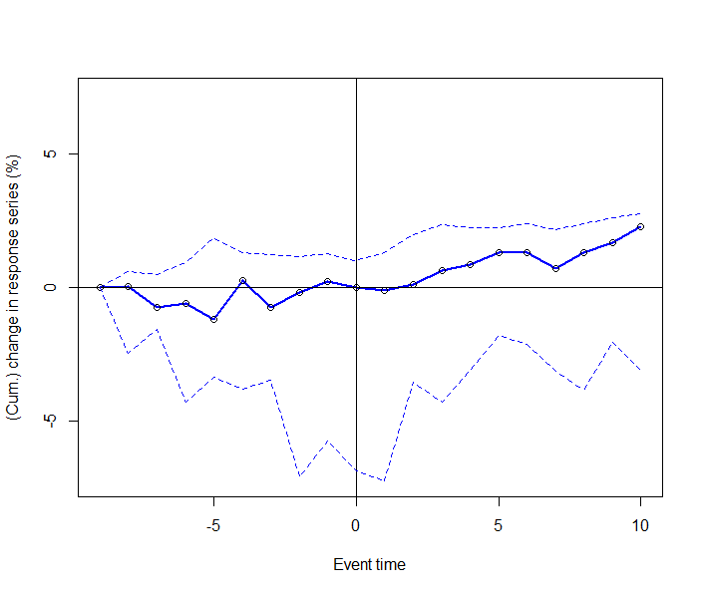

Figure 2 - 1990s

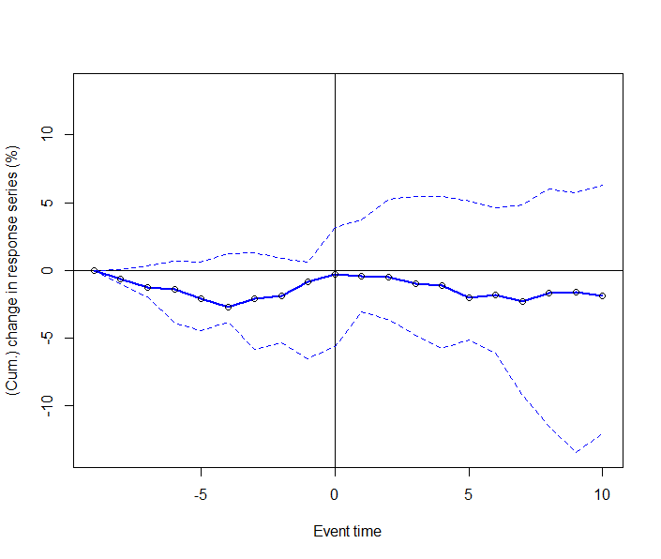

Figure 3 - 2000s

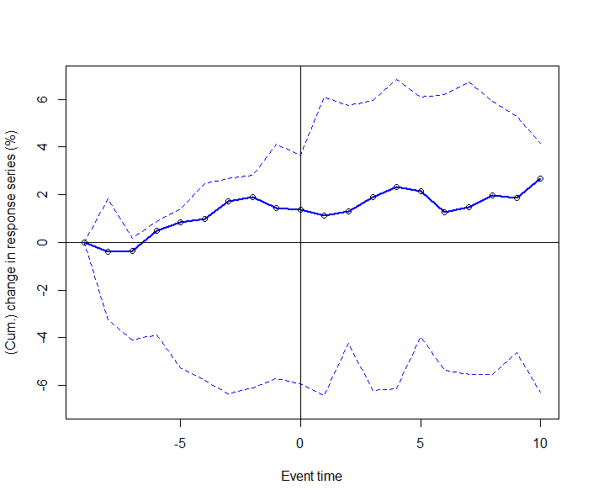

Figure 4 - 2010s

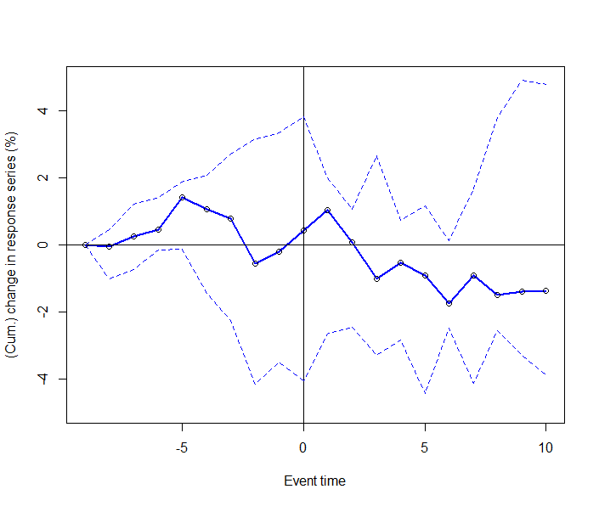

11-day Cumulative Abnormal Returns

Date event.ar event.car t.statistic.CAR p.value Stars

1 1989-01-06 0.66232093 2.51188972 7.6599670 3.126344e-05 ***

2 1982-12-23 -0.53058637 -2.02336000 -4.3112117 1.958210e-03 **

3 1985-03-19 -0.32978699 -2.94345293 -7.6566147 3.137187e-05 ***

4 1987-11-26 0.30390163 8.57361059 6.0708368 1.857109e-04 ***

5 1984-01-05 1.21050056 1.07902843 3.4663204 7.089778e-03 **

6 1998-09-03 -2.05659730 -8.80803654 -10.6316026 2.144339e-06 ***

7 1996-07-04 0.93853262 -0.45809709 -1.8511372 9.717495e-02 .

8 1992-04-29 0.71503594 10.76680442 20.1165202 8.625991e-09 ***

9 1996-02-28 0.36666393 0.25824686 0.6589509 5.264253e-01

10 1990-11-09 0.42349019 -2.41632908 -4.7874135 9.909648e-04 ***

11 2005-07-26 -0.39804163 -1.73149953 -10.0888929 3.323963e-06 ***

12 2005-09-29 -0.31336795 0.05901571 0.1641503 8.732402e-01

13 2009-03-26 1.00362358 9.31429518 8.4086376 1.483499e-05 ***

14 2001-11-29 -0.32921515 -2.53334117 -1.9758420 7.959049e-02 .

15 2003-02-20 0.86804957 0.63753679 0.8044802 4.418514e-01

16 2013-08-28 -0.44296535 -2.87920553 -5.6456846 3.153294e-04 ***

17 2016-05-26 -0.19007857 0.31372984 0.5100057 6.223187e-01

18 2016-07-05 -0.09118422 8.70387663 12.5230062 5.349497e-07 ***

19 2013-06-07 1.11829721 -5.51580053 -7.8211016 2.650627e-05 ***

20 2013-06-13 -0.09018748 -4.83543120 -7.4922664 3.722838e-05 ***

6-day Cumulative Abnormal Returns

Date event.ar event.car t.statistic.CAR p.value Stars

1 1988-12-29 0.89544460 1.7366937 5.7221986 5.275635e-05 ***

2 1982-12-15 -1.09678946 -1.6521360 -2.9691446 1.015364e-02 *

3 1985-03-08 -0.52118921 -1.9404875 -4.9002936 2.341680e-04 ***

4 1987-11-18 0.53133040 7.8845145 8.4556931 7.144237e-07 ***

5 1983-12-28 -0.00693644 0.3650612 1.1740732 2.599516e-01

6 1998-08-26 -1.88439792 -0.6461179 -1.1425963 2.723708e-01

7 1996-06-26 0.22242643 -1.4095467 -4.4309041 5.699187e-04 ***

8 1992-04-21 -0.13467994 8.6904569 20.0032298 1.072989e-11 ***

9 1996-02-20 -0.81079370 -0.3462416 -1.0545272 3.095014e-01

10 1990-11-01 -0.82365419 -3.0309148 -4.8997734 2.343955e-04 ***

11 2005-07-15 -0.68970053 -1.2347951 -9.4678772 1.830927e-07 ***

12 2005-09-21 -0.92840084 -0.8568186 -3.2329057 6.013771e-03 **

13 2009-03-18 -0.81110527 6.8157919 9.3524214 2.126731e-07 ***

14 2001-11-21 -0.15986010 0.9261784 0.8603039 4.041141e-01

15 2003-02-12 -1.18155308 -0.1237364 -0.2671087 7.932799e-01

16 2013-08-20 -0.42777954 -1.6661901 -4.5133748 4.865804e-04 ***

17 2016-05-18 -0.19245231 -0.4877265 -1.0973637 2.909987e-01

18 2016-06-24 -3.86280304 -0.7188299 -1.5862382 1.350074e-01

19 2013-05-30 0.37717913 -2.5049815 -5.6144063 6.381313e-05 ***

20 2013-06-05 -2.13240014 -2.8380251 -7.9689597 1.432813e-06 ***